* Levels

* Black&White

* Brightness&Contrast

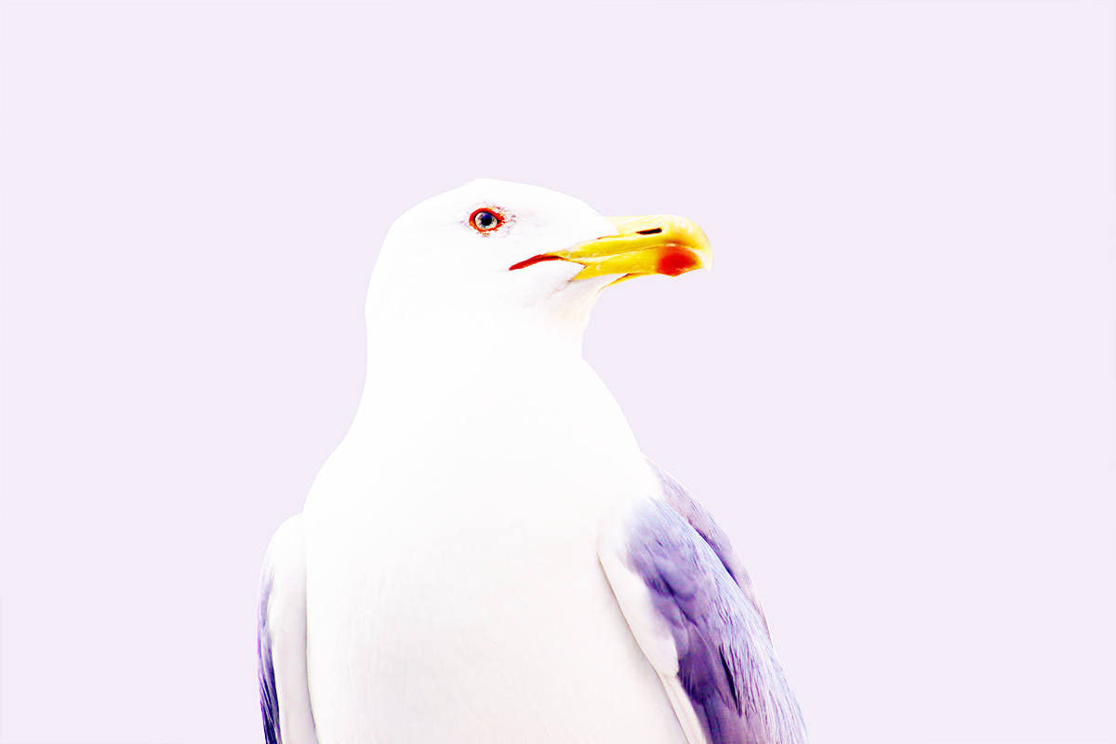

* Vibrance

